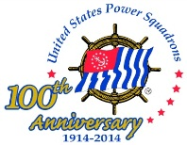 Guide to a Good Newsletter 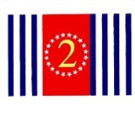
A memory-jogger for Newsletter Editors

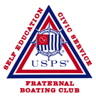
Always keep in mind our mission:
Education • Civic Service • Fraternity

Masthead:
    - Present your burgee in the masthead and the USPS logo.
    - Work on improving the design – include a fun boating photo?
    - Have your website address prominent.
    - Think about including your longitude/latitude.
    - Include District 2.
Photos and Graphics:
- Choose only the best photos, and always include captions.
- Keep graphics plain and simple and not too cute.
Information:
- List your officers with contact information.
- List upcoming squadron and D2 meetings, with registration forms when possible.
Messages:
- Highlight a message from your commander.
- Ask your SEO for a report on current and upcoming classes and students.
- Include any National news on education.
- Congratulate students who have passed exams.
- Ask your Safety Officer to write an informational/instructional article.
- Mention members’ birthdays.
Bios:
- Consider one bio per newsletter on one of our officers or a member – with a photo.
Stories:
- Include a good boating story – from a USPS publication, or written by a member.
- Check out Keeping Up! http://www.usps.org/national/pr/ which currently has 85 stories written by the Marketing and PR Department for USPS use.
Fillers:
- Keep a list of nautical terms and nautical graphics and insert them where you can. This makes the newsletter fun to look at and worth reading. These can easily be obtained from websites (Google ‘nautical terms’) or boating reference books.

National’s great Editor’s Guide is at http://www.usps.org/national/commcom/EdGuide.pdf

Remember to enter your newsletter for the Distinctive Communicator Award!
Before 1 December each year send at least four issues of your squadron newsletter to the Adviser assigned to D2: P/C Ruth Rubenfeld, JN seacastle45@aol.com

Submitted by D/C Susan Ryan, JN

